INSPECTION PLAN
Evo Basic enclosures

Note: This product will be inspected “In Process” on all materials on a “sample” basis Using an AQL of 0.65 for major defects
- General view总视图
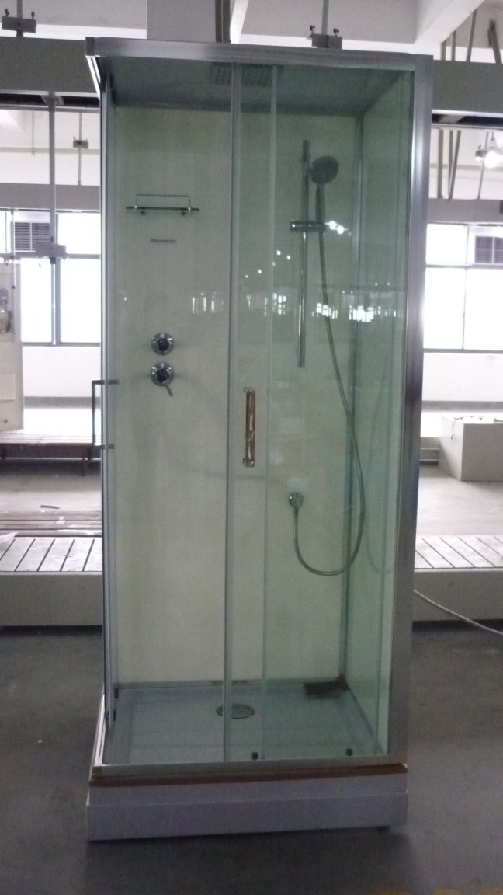
(glass 8 mm 8毫米玻璃)

Major controls 重缺陷
- Aspect外观
Major 1/ Check that each clear glass is printed with the logo below in the horizontal direction:
Label MUST Always be on LEFT side of glass !
检查每块玻璃上的商标是按水平方向印刷

Major 2/The main elements of the shower door (glass, Painted Glass, aluminium) when held vertically and examined with the naked eye, at a distance of about 60 cm for 10 seconds, must be free of defects.
Note : for Painted glass, this must be inspected from the ‘Front side’ and without any light behind the glass
在距离 60 厘米的位置用手垂直握住用肉眼看淋浴门的主要部件(玻璃,铝条)10 秒,必须无任何的缺陷

Major 3/ Ensure that the surfaces are clean. 玻璃表面必须是清洁的
Major 4/ The glass parts must not contain any defects visible at a distance of 60 cm (chipping,bubbles, colour defects, clouding in the glass, incrusted materials).
在距离身体 60 厘米的位置检查玻璃看得见的表面必须不包括任何的缺陷（碎裂，气泡，颜色不同，模糊不清，杂物等）
Major 5/ The chrome surfaces, when examined with the naked eye from a distance of about 300mm, without any magnifying device, must be free of defects.
在距离约300 毫米的位置用肉眼检查镀铬表面,不得用放大镜,必须无任何的缺陷
Major 6/ The brightness must be regular on all the chrome sections.
产品上电镀部分的亮度必须是均匀的
Major 7/ The colour of the glossed surfaces must be regular on the visible surfaces
在可视面上的上色面的色彩必须是均匀的
Major 8/ For Shower tray and top panel check that the thermal form has no black marks in the material, no scratches/scuffs or other damage to the visible surface.
Major 9/ For all PVC profiles and trims these should be checked for any cosmetic or physical damage. Also check the quantity given in the BOM
Major 10/ All other accesssories/parts should be checked for correct quantity against BOM, aspect and any physical damage. During this inspection check that the individual packaging is Ok to ensure no damage during shipment.
Major 11/ Steam Generator system should be attached to frame, check that cables are coiled and connectors are protected so they will not get damaged. Steam generator and control box should be securely mounted on frame.

- Dimensional controls (S-1 Sample size)
Major 12/ Check Glass panels, and aluminium profiles dimensions against sizes listed in BOM.
Major 13/ Check all PVC profiles, small parts for dimensions against the sizes listed in the BOM
Major 14/ Check that the plastic parts and screws are included into accessory bag, and the quantities match the quantity specified on the BOM
Special controls (S-1 Sample size)
Major 15/ Check the shower trays for leaks (Raise waste takaway pipe to above level of tray – fill tray with water and leave for at least 1 hour – check for leaks under tray after 1 hour )
Major 16/ Check the water flow through the Rainshower head – make sure water comes out of all jet nipples (it is allowed if water does not come out – to ‘Flick’ the jet to clear it – if water then flows – this is acceptable.)
底面
- Special Tests (Single unit)
Major 17/Check that the screws are in stainless steel.（1 accesories bag）
Major 18/ Fragmentation破碎测试
Place adhesive on all glass surface (Step1). Kick the glass at 100mm from each edge of a corner.Take a picture of the glass to see broken glass sizes (Step 4). Please, attach the picture in the control report.
将粘胶带粘在玻璃上(步骤1).在玻璃的角上100X100 的位置击打玻璃,将测试
后的结果拍一张照片(步骤4).然后附上照片在报告上

Major 19/ Check that all the components listed in Annex 1 are present and match the description.
Major 20/ Assembly装配
Use the exploded diagram of the shower door in Annex 2 to identify all the components and check their presence in the package.
用附件 2 上的淋浴门爆炸图,检查所有的部件, 它们也必须都出现在包装里
Check that the frame profile can be fitted in the wall profile
装在屏风上的铝条必须刚好能够装进固定在墙上的铝条
The magnets of the sliding doors must attract each other.
The screw caps for the screws must be easy to fit by hand.
螺丝上的螺丝帽必须能用手容易装配。
Major 21/ Drop Test – 1 Set of each package with Glass should be give a ‘Topple test’ (Package should be stood on end and allowed to fall forward onto floor and then fall backwards onto floor (open and check for damage)
For smaller packages these should be given a proper drop test as per normal standard according to weight.
- Packaging包装
Minor1/ Check that each element of glass is protected with bubble paper and EPS
每个玻璃材质的组件用汽泡纸和泡沫保护。
Minor2/ Check that the wall profiles are protected with a bubble paper.
靠墙铝条用气泡纸保护
Minor3/ All the fastenings and accessories for assembly must be packed in a plastic bag.
所有安装用的扣件和配件必须包装在1 个塑料袋里
Minor4/ Check that the packaging is according to picture here below :
检查包装如下图
(To Be Added Later)

Minor5/ Make sure that the quality of the cardboard and the weight of the part do not
entail a risk of damaging the elements of the concept or the packaging.
确保纸箱质量能承受自身重量和包装不被损坏的风险

AQL

MAJOR :

General Level II

AQL : 0.65

MINOR

General Level II

AQL : 2.50

S-1

AQL : 0.65

Appendix 1 - BOM for EVO Basic 70 x 90
Appendix 2 - Assembly instructions for Evo Basic 70 x 90

